**Looking for Religions**

There are many different religions in the world. In Religious Education lessons, you will learn about some of these religions. These lessons will allow you to explore ideas about other people’s beliefs and how this affects their lives. Over the last 30 years, the area of Newcastle has **changed** greatly. There are now many different religious communities living here. Your mission is to look for evidence of the religions listed on the chart below.

Use as many

Sources as you can.

|  |  |  |
| --- | --- | --- |
| **Religion** | **Any evidence?**  [tick](http://images.google.co.uk/imgres?imgurl=http://www.vedicmaths.org/Introduction/Tutorial/graphics/tick.jpg&imgrefurl=http://www.vedicmaths.org/Introduction/Tutorial/Tutorial.asp&h=34&w=34&sz=1&hl=en&start=5&um=1&tbnid=FNH281TMTh_78M:&tbnh=34&tbnw=34&prev=/images%3Fq%3Dcorrect%2Btick%26svnum%3D10%26um%3D1%26hl%3Den%26rls%3DGGLR,GGLR:2006-33,GGLR:en) or [pub_cross](http://images.google.co.uk/imgres?imgurl=http://www.cpr.co.uk/images/pub_cross.gif&imgrefurl=http://www.cpr.co.uk/publicity_photos01.htm&h=75&w=85&sz=2&hl=en&start=3&um=1&tbnid=evcRU1gL5rrWFM:&tbnh=67&tbnw=76&prev=/images%3Fq%3Dcross%2Bmark%26svnum%3D10%26um%3D1%26hl%3Den%26rls%3DGGLR,GGLR:2006-33,GGLR:en) | **Type of evidence**  **e.g.** religious building,  internet research, symbols,  religious followers. |
| Judaism |  | [http://tbn0.google.com/images?q=tbn:3uvGaB2kDCQIEM:http://www1.istockphoto.com/file_thumbview_approve/391190/2/istockphoto_391190_jewish_rabbi.jpg](http://images.google.co.uk/imgres?imgurl=http://www1.istockphoto.com/file_thumbview_approve/391190/2/istockphoto_391190_jewish_rabbi.jpg&imgrefurl=http://www.istockphoto.com/file_closeup/%3Fid%3D391190%26refnum%3D361997%26Lang%3Den&h=380&w=222&sz=26&hl=en&start=3&um=1&tbnid=3uvGaB2kDCQIEM:&tbnh=123&tbnw=72&prev=/images%3Fq%3Dcartoon%2Brabbi%26svnum%3D10%26um%3D1%26hl%3Den%26rls%3DGGLR,GGLR:2006-33,GGLR:en) |
| Christianity |  |  |
| Hinduism |  |  |
| Islam |  |  |
| Buddhism |  |  |
| Sikhism |  |  |

Which religions have no place of worship in your neighbourhood?

----------------------------------------------------------------------------------

**Come dine with us!**

Some religions have rules on what foods they should and should not eat. These rules usually come from their holy books that give guidance on what foods can and cannot be eaten. Your task is to look at the descriptions given of what each person can and cannot eat. You have to design a menu that includes meals everyone can enjoy.

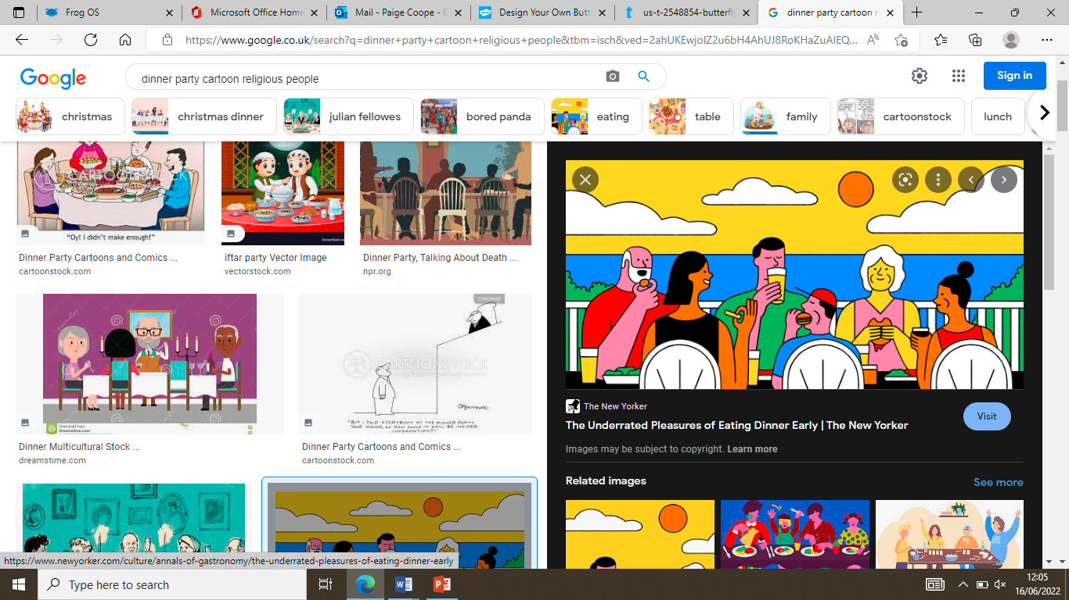

C:\Program Files\Microsoft Office\MEDIA\CAGCAT10\j0285926.wmf

**Noah is Jewish, these are his requirements for food:**

* He cannot eat shellfish (crab, prawns, lobster)
* He cannot eat pork
* He cannot eat dairy (cheese and milk) and meat together in one meal. E.g. no chicken and egg, no cheese and beef!)

**Aruna is a Hindu, and these are her requirements for food:**

* She cannot eat beef as she believes cows are sacred animals
* Milk is allowed
* Often she will avoid eating meat so that animals are not harmed

[](http://images.google.co.uk/imgres?imgurl=http://www.atmajyoti.org/images/om_yellow_marblish.gif&imgrefurl=http://edubuzz.org/blogs/mgsrmps/&usg=__XO879lcBH0kHS7MMeBmQwBWGfiU=&h=302&w=300&sz=19&hl=en&start=22&um=1&itbs=1&tbnid=lObLJxQlKQdj4M:&tbnh=116&tbnw=115&prev=/images%3Fq%3DHindus%26ndsp%3D18%26hl%3Den%26rlz%3D1W1TSEA_en-GB%26sa%3DN%26start%3D18%26um%3D1)

[](http://images.google.co.uk/imgres?imgurl=http://webzoom.freewebs.com/muslims_unite/muslim.jpg&imgrefurl=http://www.freewebs.com/muslims_unite/&usg=__5TO-CDt3Dmul31sMoDkAZtlGf_Q=&h=240&w=259&sz=14&hl=en&start=51&um=1&itbs=1&tbnid=IGJB90XRHxA6VM:&tbnh=104&tbnw=112&prev=/images%3Fq%3DMuslims%26ndsp%3D18%26hl%3Den%26rlz%3D1W1TSEA_en-GB%26sa%3DN%26start%3D36%26um%3D1)

**Ahmed is Muslim, and these are his food requirements:**

* He cannot eat pork
* However, lamb, beef and chicken are ok
* Fish and eggs are ok too
* No shellfish (such as crab, prawns and squid)
* No alcohol

Using the information provided on each dinner guest, your task is to create a menu that has **one** meal on it that **each person** can have.

You might create a starter that Aruna can eat, a main meal suitable for Noah and a dessert for Ahmed.

You can create the meals for anyone, as long as each person has something they can eat.

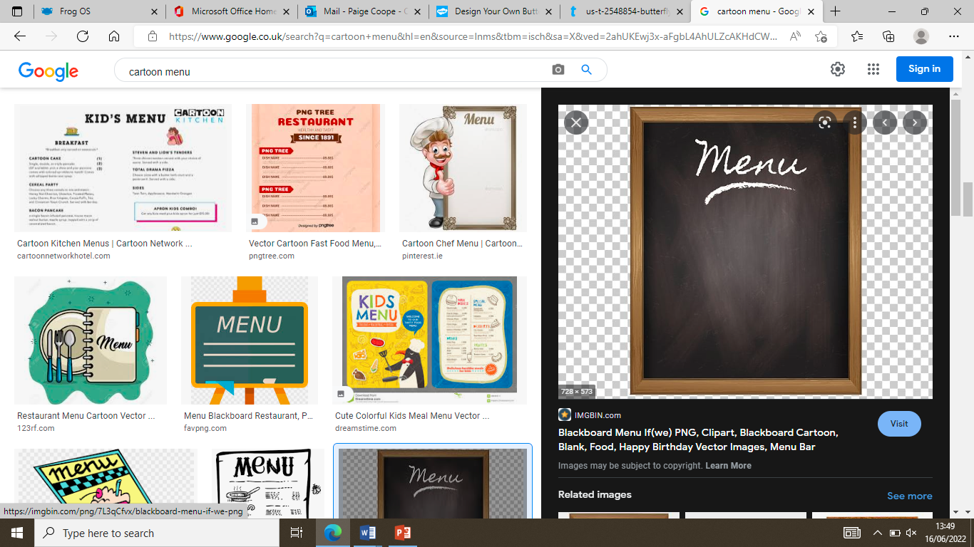

**My starters: \_\_\_\_\_\_\_\_\_\_\_\_\_\_\_\_\_\_\_\_\_\_\_**

**My main meals: \_\_\_\_\_\_\_\_\_\_\_\_\_\_\_\_\_\_\_\_\_**

**My desserts: \_\_\_\_\_\_\_\_\_\_\_\_\_\_\_\_\_\_\_\_\_\_\_**

[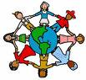](http://images.google.co.uk/imgres?imgurl=http://www.d.umn.edu/~gbabiuk/images/children-holding-hands_000.jpg&imgrefurl=http://www.d.umn.edu/~gbabiuk/TeachersToolKit.htm&h=175&w=189&sz=14&hl=en&start=16&um=1&tbnid=I8AJz64X59JgyM:&tbnh=95&tbnw=103&prev=/images%3Fq%3D%2Bcartoon%2Bchildren%2Bholding%2Bhands%26svnum%3D10%26um%3D1%26hl%3Den%26rls%3DGGLR,GGLR:2006-33,GGLR:en) **Guidelines for living.**

Many religious people follow rules which are set out in

their holy book. Religions teach their followers to be kind to one another, and help those who are in need. All of us have to follow certain rules, e.g. ‘no running’ in school. These rules help us to be thoughtful towards others

Can you think of 5 rules that will help make the world a happier place for everyone? Write them in the space below.

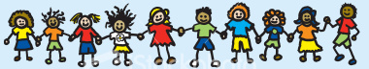

1.-----------------------------------------------

2.-----------------------------------------------

3.-----------------------------------------------

4.-----------------------------------------------

5.-----------------------------------------------

Write a sentence explaining which rule is best and would help make the world a happier place:------------------------------------------------------------------------------------------------------------------------------------------

------------------------------------------------------------------------------------------------------------------------------