Part of the bar has been shaded.
3

Ratio and fractions

- Here are some counters.

Complete the sentences to describe the counters.

  - There are counters altogether.
- What fraction of the bar is shaded?

- What fraction of the bar is not shaded?

  - There are
white counters.
  - Write the ratio of shaded to non-shaded parts. to

- There are

black counters.

- Write the ratio of non-shaded to shaded parts. to

- 3 out of the 8 counters are

- out of the 8 counters are white.

Here are some shapes.
4

- Here are some animals.
  - What fraction of the shapes are circles?

  - What fraction of the shapes are stars?

Complete the sentences.

For every cows there are sheep. The ratio of cows to sheep is to

  - What is the ratio of stars to circles? to

  - What is the ratio of circles to stars? to

of the animals are cows.
Can you find a different answer to each of these questions? Compare with a partner.

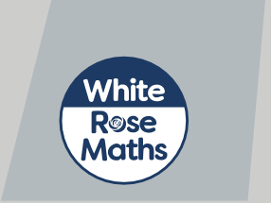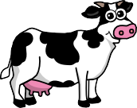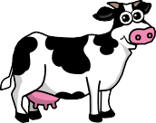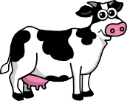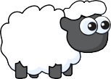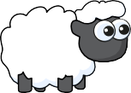of the animals are sheep.

© White Rose Maths 2019

7
Scott draws a bar and divides it into 8 equal parts.
He shades 25% of the bar.
What is the ratio of shaded to non-shaded parts?
to
A pencil case contains felt tips and pencils.
3 of the contents are pencils.
8
What is the ratio of felt tips to pencils?
to
9
Ron has some limes and strawberries.

The ratio of strawberries to limes is 5 to 1

a) How do you know he has more strawberries than limes?
b) What fraction of the fruits are strawberries?
c) What fraction of the fruits are limes?
© White Rose Maths 2019
8

The bar model shows the ratio 1 to 3 to 4
5

Talk to a partner about how it shows this.

- What fraction of the bar is striped?

- What fraction of the bar is fully shaded?

- What fraction of the bar is blank?

6

The fraction of brown cubes
3
brown to yellow is 2 to 3
is 2 because the ratio of
Jack
The fraction of
brown cubes is 2
5
Rosie
Who is correct? Explain your answer.

