*********************************************
** **
** **
** **
** **
Year 6
Spanish Transition Work
** **

* *
** **
* *
* *
* *
* *
* *
* *
* *
* *
* *
* *
* *
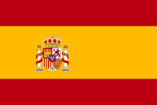
* *
* *
* *
* *
* *
* *
* *
* *
* *
* *
* *
* *
* *

***********************************************

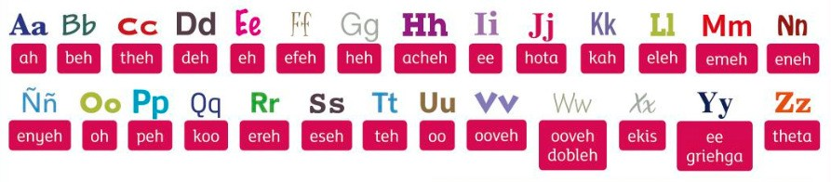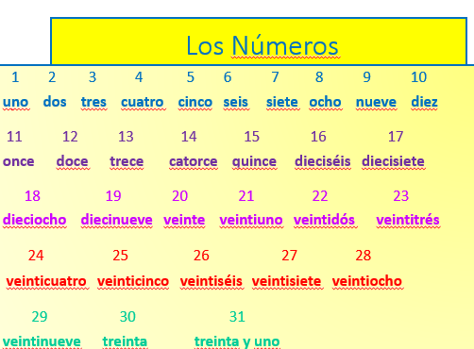Activity 1 – Numbers

Complete these sums:

- dos + diez =
- quince – uno =
- treinta – diez =
- ocho x tres =
- doce - dos =
- veintisiete – nueve =
- treinta y uno – seis =
- once + diez =
- treinta – cero =
- catorce x dos =

Activity 2 – Spanish Alphabet
Using the Spanish Alphabet below, write the spelling of each name

Ejemplo: David. Se escribe deh, ah, ooveh, ee, deh

1. Javier - …………………………………………………

2. Jorge - …………………………………………………

3. Irene - …………………………………………………

4. Alicia - ………………………………………………..

5. Claudia - …………………………………………….

Activity 3 – Months
Write the months out in order (start with Jan)

1.

2.

3.

4.

marzo agosto

junio septiembre enero julio febrero
octubre mayo

5.

6.
diciembre

noviembre
abril

7.

8.

9.

10.

11.

12.

Activity 4 – Translate these birthdays

- Mi cumpleaños es el veinticuatro de marzo –
- Mi cumpleaños es el dieciocho de junio –

- 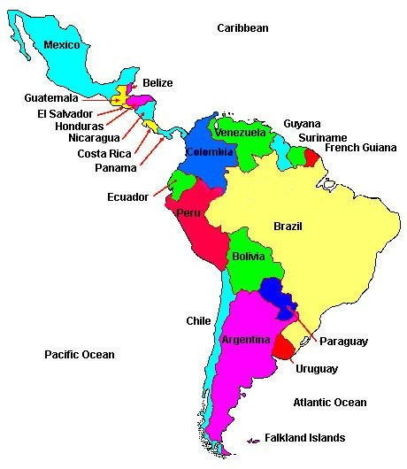Mi cumpleaños es el treinta y uno de mayo –
- Mi cumpleaños es el veintidós de enero –
- Mi cumpleaños es el quince de febrero –
- Mi cumpleaños es el primero de abril -

When is your birthday? Write it below in Spanish:

………………………………………………………………………………………………

The Spanish Speaking World

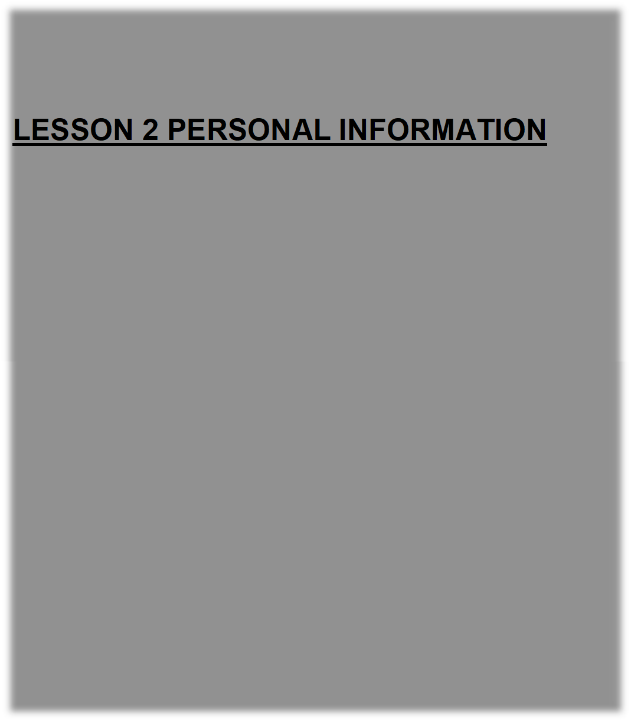
LESSON 2 PERSONAL INFORMATION

Activity 5 – Which countries speak Spanish?

Spanish is spoken by 550 million people in the world! The countries with the most Spanish speakers are Mexico, USA, Spain, Colombia and Argentina. Use the internet to make a list of other Spanish speaking countries:

1. 8.
2. 9.
3. 10.
4. 11.
5. 12.
6. 13.
7. 14.

Activity 6: Fill in the countries from the map in activity 1. Be careful there are a few that don’t speak Spanish.

Norteamérica | Centroamérica | Sudamérica
México

Activity 7 – Write the colours in Spanish. Use the box to help you:

Yellow –
Blue –
White –
Grey –
Brown –
Purple –
Orange –
Black –
Red –
Pink –
Green –
Light – | claro/a
Dark – | oscuro/a

naranja
gris
amarillo/a rosa
negro/a
verde
rojo/a
marrón
azul
blanco/a
morado/a
Design some flashcards to help you remember the colours you still find difficult to remember.

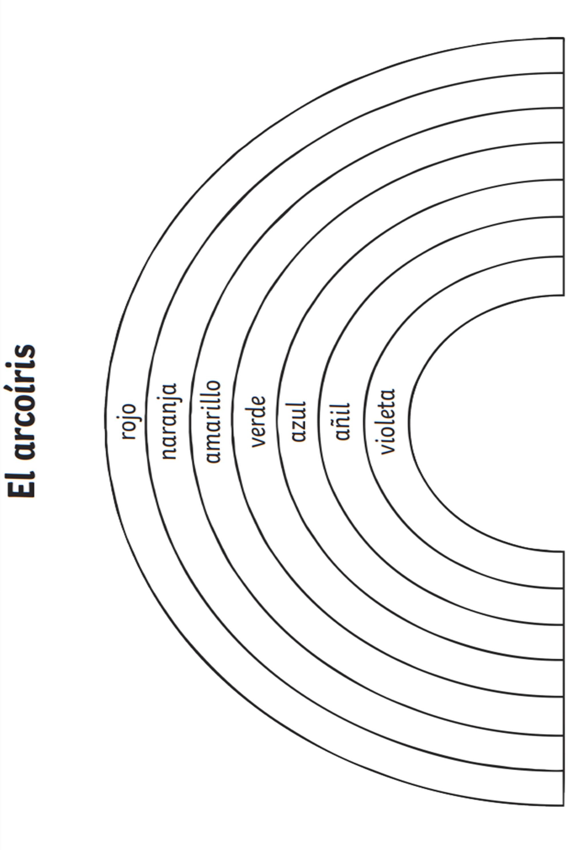Activity 8:
Have you coloured in a rainbow and stuck it on your window? Try colouring in this Spanish version:

