Year 6
Chinese Mandarin Transition Work

Where in the World Is China?
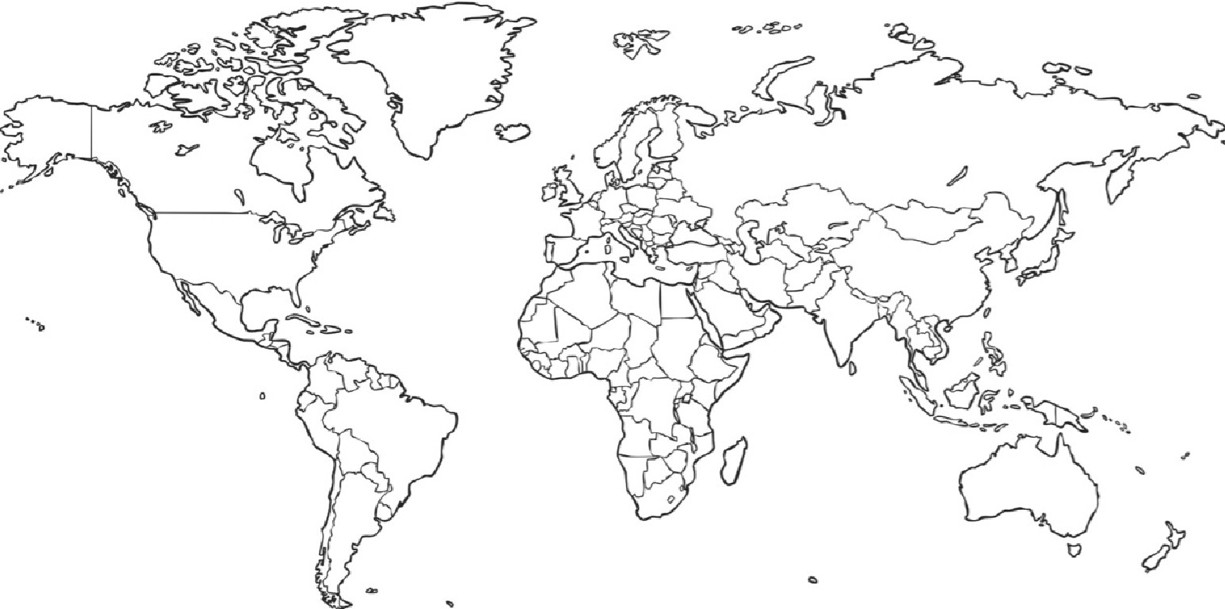

a} Colour and label China on the world map.
- What continent is China located in?

Colour and label the United Kingdom on the world map.

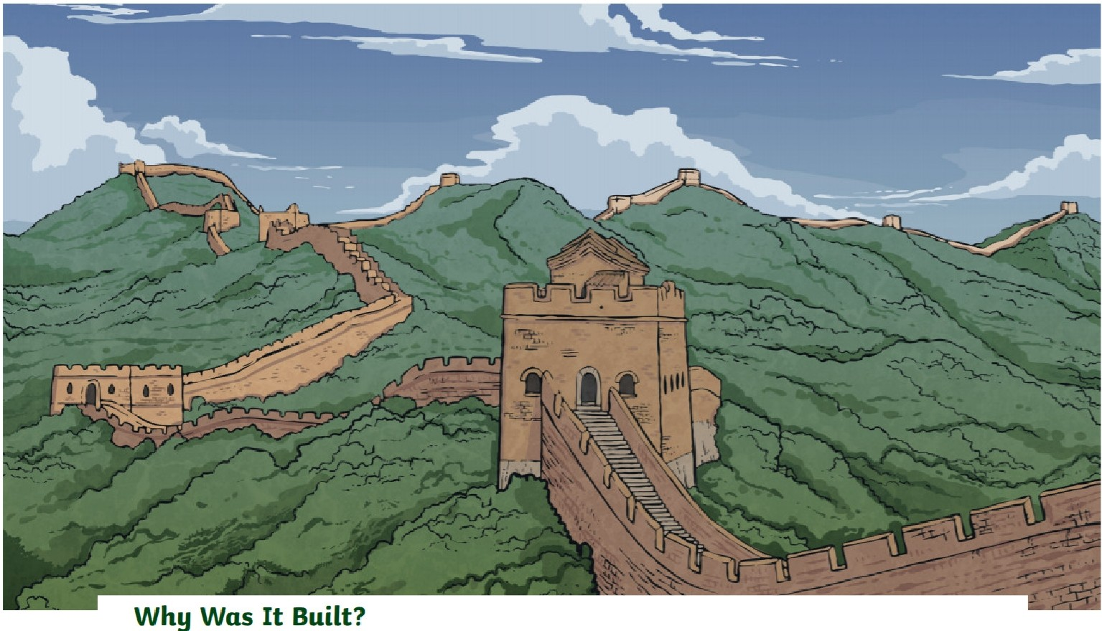
The Great Wall of China
Tne Great Wall of China was originally built to defend China's border and protect trade.
Interesting Facts
Construction of the Great Wall began between 220 and 206BC.
The Great Wall stretches for 21195 Rllometres across northern Ch ina.
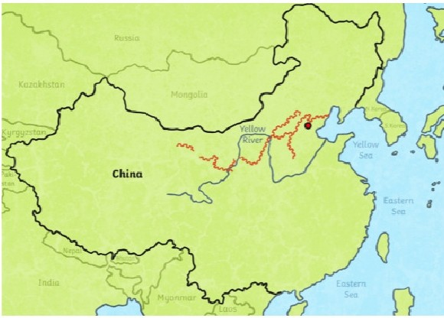
The top of the wall is wide enough for people, animals and carts to travel along it. People who were being punished , such as criminals and slaves, originally built the wa ll.
It took over 1000 years to build and millions of people built it.
The wall has over 7000 looRout towers.
Approximately 10 million visitors are attracted to it each year.

Na m e: Da te :

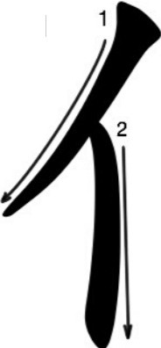
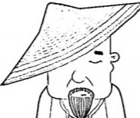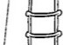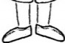p e rson
I
\
.
radical

ta
he i him
nT
men
eh!.ra l
..

.
·-f' t··  ' |  | . . |  |  | '  . .'' . . . . | . | ""':t--- | :' · |  |  |  | '  '  . .......  ' | .....- - -  ' | . .' ..  '
 |  |  |  | ''  '' |  |  |  | '  ' | . ' | . | I

·1.t·· | '  .l i....  '.' | . .... | '  ........  . | . .. --  ' | '  . 'f ··  i, | . r,;:'..  ... | . I --- | ''  .'..- '  '

' ' '
' | . / | . .. | ... | . . |  | ' | . 4...... | 1'  . 1t·· | -11- -- | ----.. ----  .. |  | .  - - -...----  .
·1111 ·· |  |  |  |  | l | '\· --·  '' |  |  |  |  | --------

n ote : In is used to indicate the plural form for people only e.g In = th ey/t h em. {/Jlfn =you (plu ra l)

I No m e: Da t e:
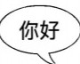
speech
, 1

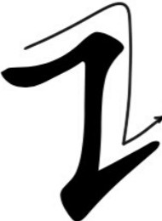
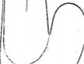radical

2

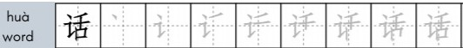

shuo
speak
.,--uI' . | . ... .... | . -1·. . . . . | -1' · .... | i:···· | . -1 ....... | ·""I+'-- | ·1¥.: | ·1,j1 . | t.-·

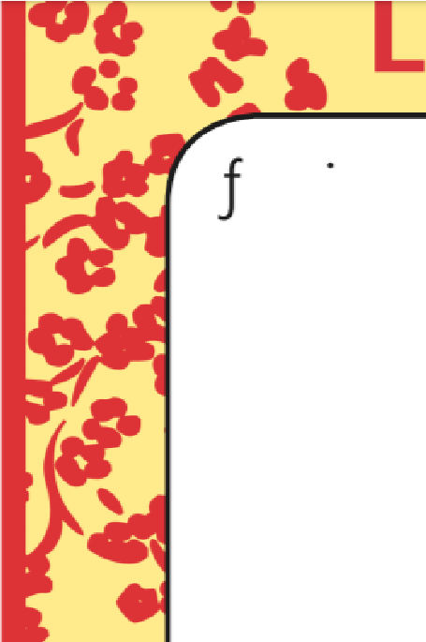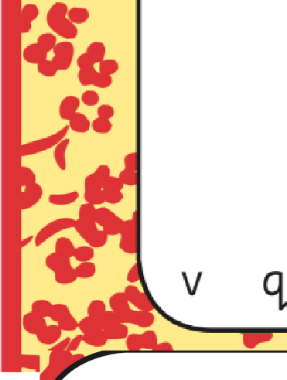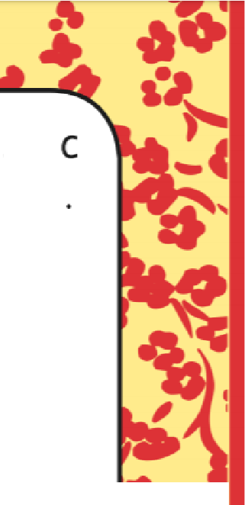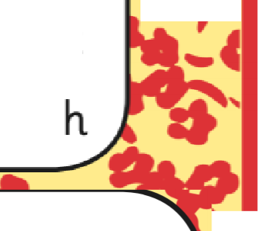
V
et s Go to
..,.
..
s y l
a
J
a
f
s
e
.,t·>,
k 0 e e
J
l
h. V t
Asia
China Beijing Sh.an.g h.ai Himalayas
Mount Everest
Yangtze River
Yellow River city town nee
silk

 | l | X | b | e | l | j | l | n. | g | k
n. | R | w | r | 0 | g | y | w | y | y | X | L
m | 0 | u | n. | t | e | V | e | r | e | s | t
C h. l n. a f b s l V t y
n. | t | 0 | w | n. | y | e | l | n. | h. | f j
h. | l | m | a | l | a | y | a | s | h. | 0 p

J  n. | s  g | h  t | a  z | n.  e | g  r | h  l | a  V | l  e | 0  r
s |  | p | r | 0 |  | l | a | r | w
 | a | m | b | z | r | l | C | e | n
l |  | 0 | w | r | l | V | e | r | t

