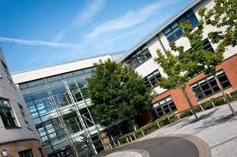
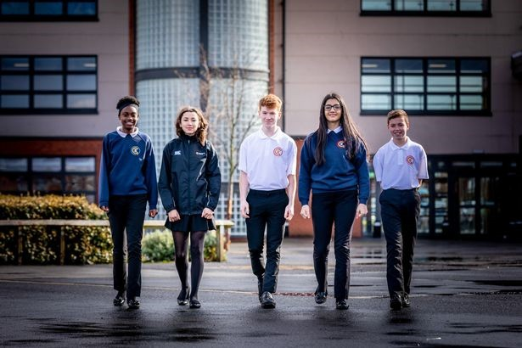
Moving from Primary to Secondary School is a big change, but it is also an exciting time! A new building, new rules, new teachers, new routines and new friends are just some of the changes you will experience but this booklet will help you get used to some of the routines and features of your new school!

Name:
Draw a self portrait here.

Birthday:

My Primary School:

Favourite Colour
Favourite Animal
If I could have a superpower, I’d….
Favourite School Subject
Best place I’ve ever been to…
Dream country to visit…
If I could travel back in time, I’d go to…
My dream job is…

Life is a journey! Think back through primary school and write down your favourite memories or events that have shaped you to become the amazing person you are!

Full Name of the School
School Address
School Telephone Number
Name of the Head Teacher
School Starts at
School Finishes at
I will get to school by
How long will it take you to get to school?
What time will you have to leave home?
Add 10 words around the image below to describe your new school .

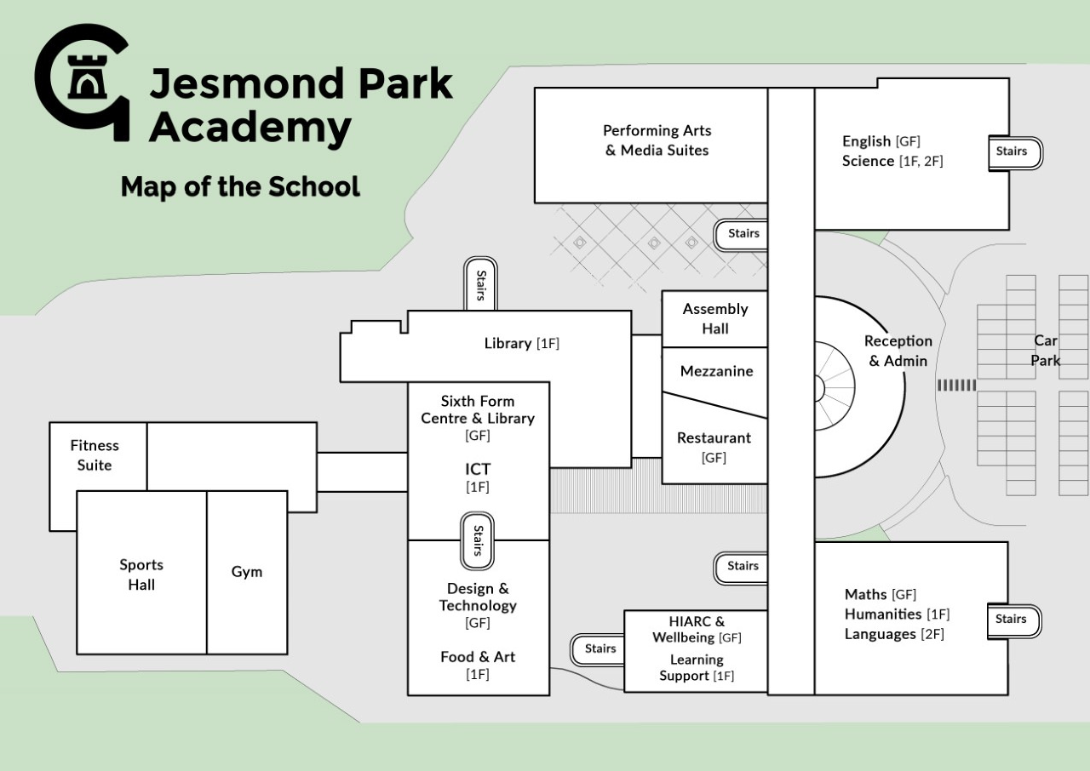Look at the map of Jesmond Park Academy and answer the following questions:
GF = Ground Floor
1F = First floor
2F = Second Floor

- How many sets of stairs are there in school? …………………..

- Which subject has classrooms over 2 floors? …………………...

- Which subject area is above Humanities? ………………………

- Draw a line on the map to show how you would get from Maths to English

- Which subject shares an area of the school with Media Studies?

………………………………………….

- Put on cross on the stairs you would use to get from Art to Design & Technology

- List 4 things you are most excited about moving to Jesmond Park Academy
1.
2.
3.
4.
- List 4 things you are a little nervous about 1.
2.
3.
4.
- List 4 things you would like to know about Jesmond Park Academy
1.
2.
3.
4.
- List 4 things that will help you when moving to Jesmond Park Academy
1.
2.
3.
4.
- List 4 differences between your primary school and Jesmond Park Academy
1.
2.
3.
4.

Find the activities below in the Word search – they are vertical, horizontal and diagonal!

M | A | F | S | E | H | M | G | E | O | H | I | M | J | E | E | A
F | M | A | M | W | S | L | U | S | M | I | S | E | T | T | I | S
R | U | D | A | N | C | E | Z | S | A | C | P | N | U | H | A | I
A | F | G | T | R | D | P | W | R | I | I | A | G | T | I | N | U
H | S | R | H | P | G | R | T | E | N | C | I | T | O | C | A | O
J | T | A | S | L | U | B | N | Y | R | A | N | E | R | S | S | L
T | U | B | J | E | I | C | Q | L | E | R | M | X | T | A | S | S
E | E | A | U | H | E | M | U | A | H | S | U | D | I | N | E | P
N | F | X | L | G | E | O | G | R | A | P | H | Y | M | D | M | A
G | I | M | T | V | M | A | I | T | Y | E | O | A | E | M | B | N
L | O | A | I | I | O | T | O | H | R | T | T | S | C | O | L | I
I | P | T | E | E | L | G | R | D | U | O | E | R | A | R | Y | S
S | P | U | F | O | S | E | E | K | R | M | P | T | T | A | E | H
H | I | S | T | O | R | Y | S | C | S | A | S | M | E | L | R | A
E | N | J | V | E | P | I | F | J | N | O | M | U | R | S | B | K
J | K | C | A | T | E | R | I | N | G | C | N | A | R | P | U | M
Y | Z | X | T | L | S | V | Z | C | O | M | P | U | T | I | N | G

Maths English Science Geography History
Art

Computing Assembly Tutor Time Music
PE

Drama

Match up the activity to the correct icon

Maths English Science Geography History
Art Music PE

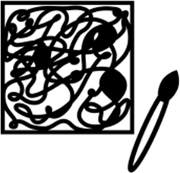
Drama Food Tech Computing Languages Tutor Time

Example Timetable

 | Monday | Tuesday | Wednesday | Thursday | Friday
Tutor 08:30-08:45 | TUTOR TIME | TUTOR TIME | TUTOR TIME | TUTOR TIME | TUTOR TIME
Period 1  08:45-09:35 | MATHS TAS B4 | SCIENCE ECU D11 | ENGLISH JTR B10 | FOOD TECH DMI D2 | PE  LSA Hall
Period 2  09:35-10:25 | ENGLISH JTR B10 | MATHS TAS B4 | HISTORY ZCB D3 | FOOD TECH DMI D2 | PE  LSA Hall
BREAK 10:25-10:40
Period 3  10:40-11:30 | GEOGRAPHY SKO D9 | ENGLISH JTR B10 | LANGUAGES VDI A5 | LANGUAGES VDI A5 | MATHS TAS B4
Period 4  11:30-12:20 | SCIENCE ECU D11 | ENGLISH TOB LRC | MATHS TAS B4 | SCIENCE ECU D11 | GEOGRAPHY SKO D9
LUNCH 12:20-13:00
Period 5  13:00-13:50 | COMPUTING THU A3 | ART TMI B8 | DRAMA  ARO Studio | CITIZENSHIP VDI A5 | ENGLISH JTR B10
Period 6  13:50-14:40 | SCIENCE EFB B11 | FOOD TECH DMI E3 | PE  KWA Studio | MUSIC TMO E2 | HISTORY ZCB D3
Extra- Curricular 14:40-15:30 |  | DRAMA CLUB |  |  | FITNESS CLUB
Use the example timetable above to answer these questions:
  - What lesson is on at 14:00 on Thursday?.......................................
  - What are the initials of the Geography teacher? ………………………..
  - How many minutes does each lesson last? …………………………………
  - How long is tutor time? …………………………………………………………..
  - How long is lunch and break combined? …………………………………...
  - Which room is PE in? ……………………………………………………………..
  - How many times a week does this student have the following:
    - Maths: ………………………………..
    - English: ……………………………….
    - History: ……………………………….

At secondary school, you will be moving around to different classrooms for different lessons. You could be in 6 classrooms in one day. This means that you need to bring all the equipment you will require with you for the day. Below are some items you will need to bring – can you identify them and add anything else?
School will provide the planner so you don’t need to purchase one before starting school.
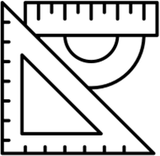

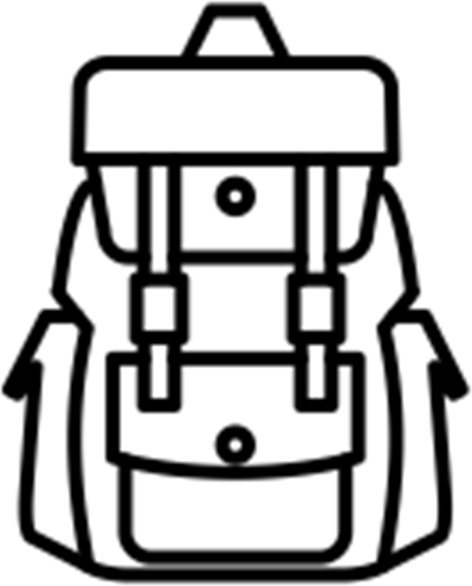

We pride ourselves in looking smart and professional at all times. Use the school website or the information booklet to draw and label the school uniform you will wear onto the Lego figure

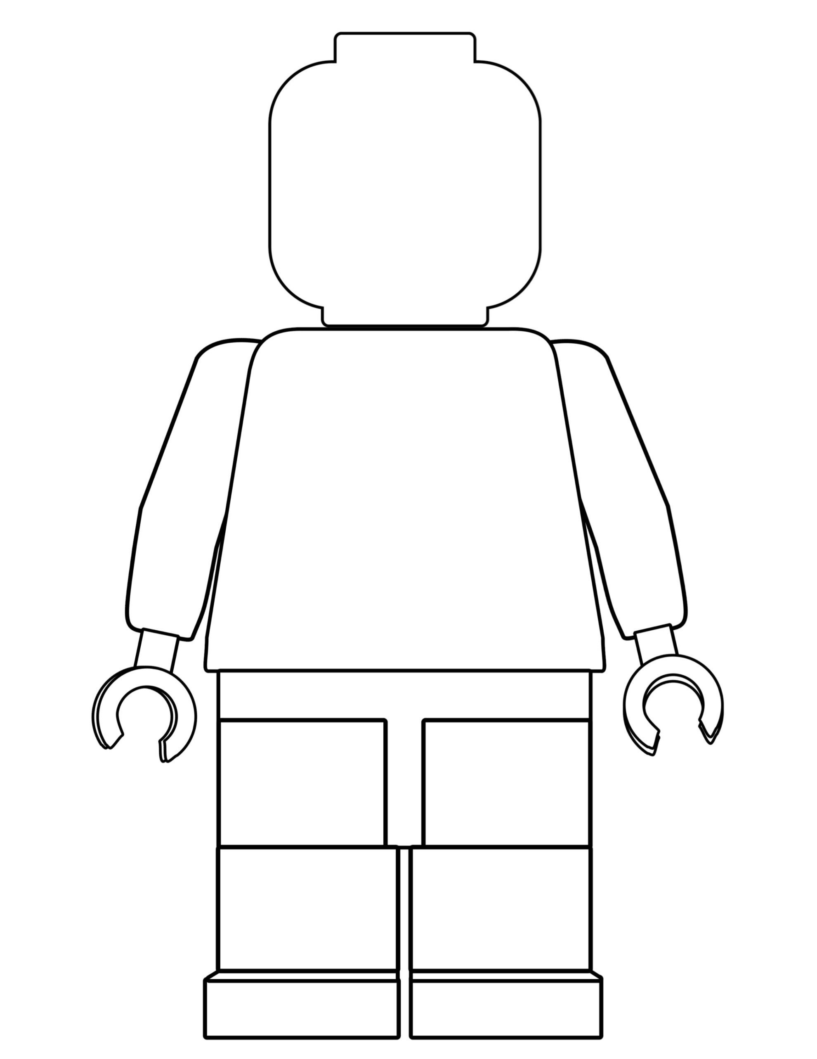

Why is wearing the correct school uniform important?
……………………………………………………………………………………
……………………………………………………………………………………
……………………………………………………………………………………
……………………………………………………………………………………
……………………………………………………………………………………

Getting to Jesmond Park Academy safely is just as important as being there. In the box below, draw the route you are going to take to school (whether that’s walking, cycling, driving or by bus). Identify spots where there could be hazards (e.g. busy roads) and explain how you will manage this safely!

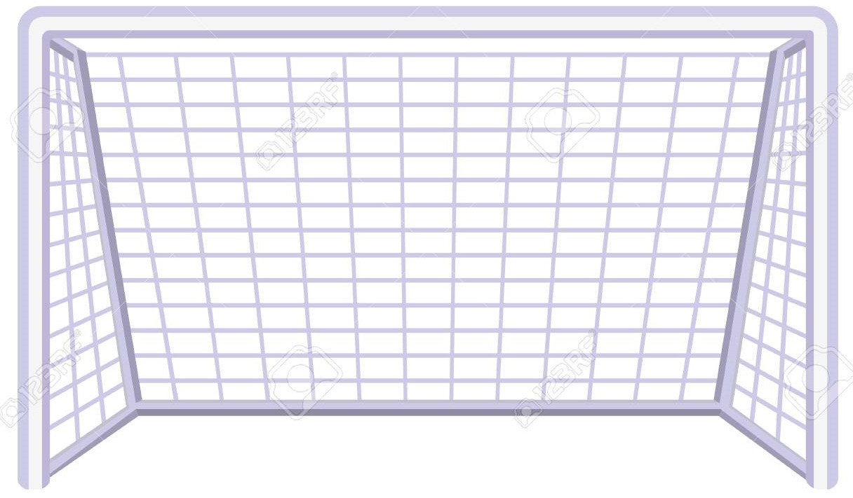
When you go to Secondary School, you will learn a huge number of new skills, and improve skills you have practiced in Primary School. In the goal below, use the list to write in 10 new skills or things you’d like to build on in your years at Secondary School.

Be in a school play or production | Speak another language | Represent your school in a national competition
Learn to play a musical instrument | Volunteer in the local community | Travel to another country
Play for a school team | Speak to a large group of people | Learn how to grow plants
Learn how to manage money | Taste food from another country | Work as part of a team
Cook a new meal from scratch | Read new books | Make new friends from other schools
Create a piece of art | Raise money for charity | Become a member of the student council
Learn how to read a map | Join an after school club | Learn to dance
Use computers to create your own website | Learn First Aid | Improve your singing

After secondary school, you can move onto college or an apprenticeship and then to University or into a job! It’s normal not to know what you want to do yet but this is a chance for you to have a think about your dream jobs!
Icons to represent that job:

Icons to represent that job:
Icons to represent that job:

