Order On-Line, and pay by credit-card at https://emblematic.co.uk/longbenton-store/jpa/

CODE | ITEM | Please indicate below which colour you require embroidering on to your garment |  |  |  |  | SIZE | QTY | AMOUNT
 |  | BLUE Year 7 | GREEN  Year 8 | RED  Year 9 | YELLOW  Year 10 | PINK  Year 11
Trutex  (CJS-NAV) | NAVYSWEATSHIRT  XXSmall, XSmall- £12.00  Small, Med, Large, XL, 2XL, 3XL - £13.00
Trutex  (KES-WHT) | WHITE POLO SHIRT  XXSmall, XSmall- £9.00  Small, Medium, Large, XL, 2XL, 3XL - £10.00
Result (R114/B/M) | BLACK SCHOOL FLEECE  8/10(MY), 10/12(LY), 12/14(XLY)- £16.50  Small, Medium, Large, XL, 2XL, 3XL - £16.50
Canterbury | BLACK SCHOOL COAT  Age 10, Age 12, Age 14 (XS) - £39.50  Small, Medium, Large, XL, 2XL, 3XL - £39.50
 |  | TOTAL AMOUNT |  |  |  |  |  |  | £

Ordering:
1) Order online via a dedicated page at https://emblematic.co.uk/longbenton-store/jpa/
2) Stock will be available to Purchase at our Shop.
3) Emblematic will be visiting the School at certain times of the year.

Deliveries:
If delivery is paid you may have it delivered to an address of your choice.

Shop opening times are as follows. Monday to Friday 10:00am – 17:00pm.
Saturday (June-September Only) 10:00am – 16:00pm.

Contact Details: All Queries/Updates - Customerservices@emblematic.co.uk

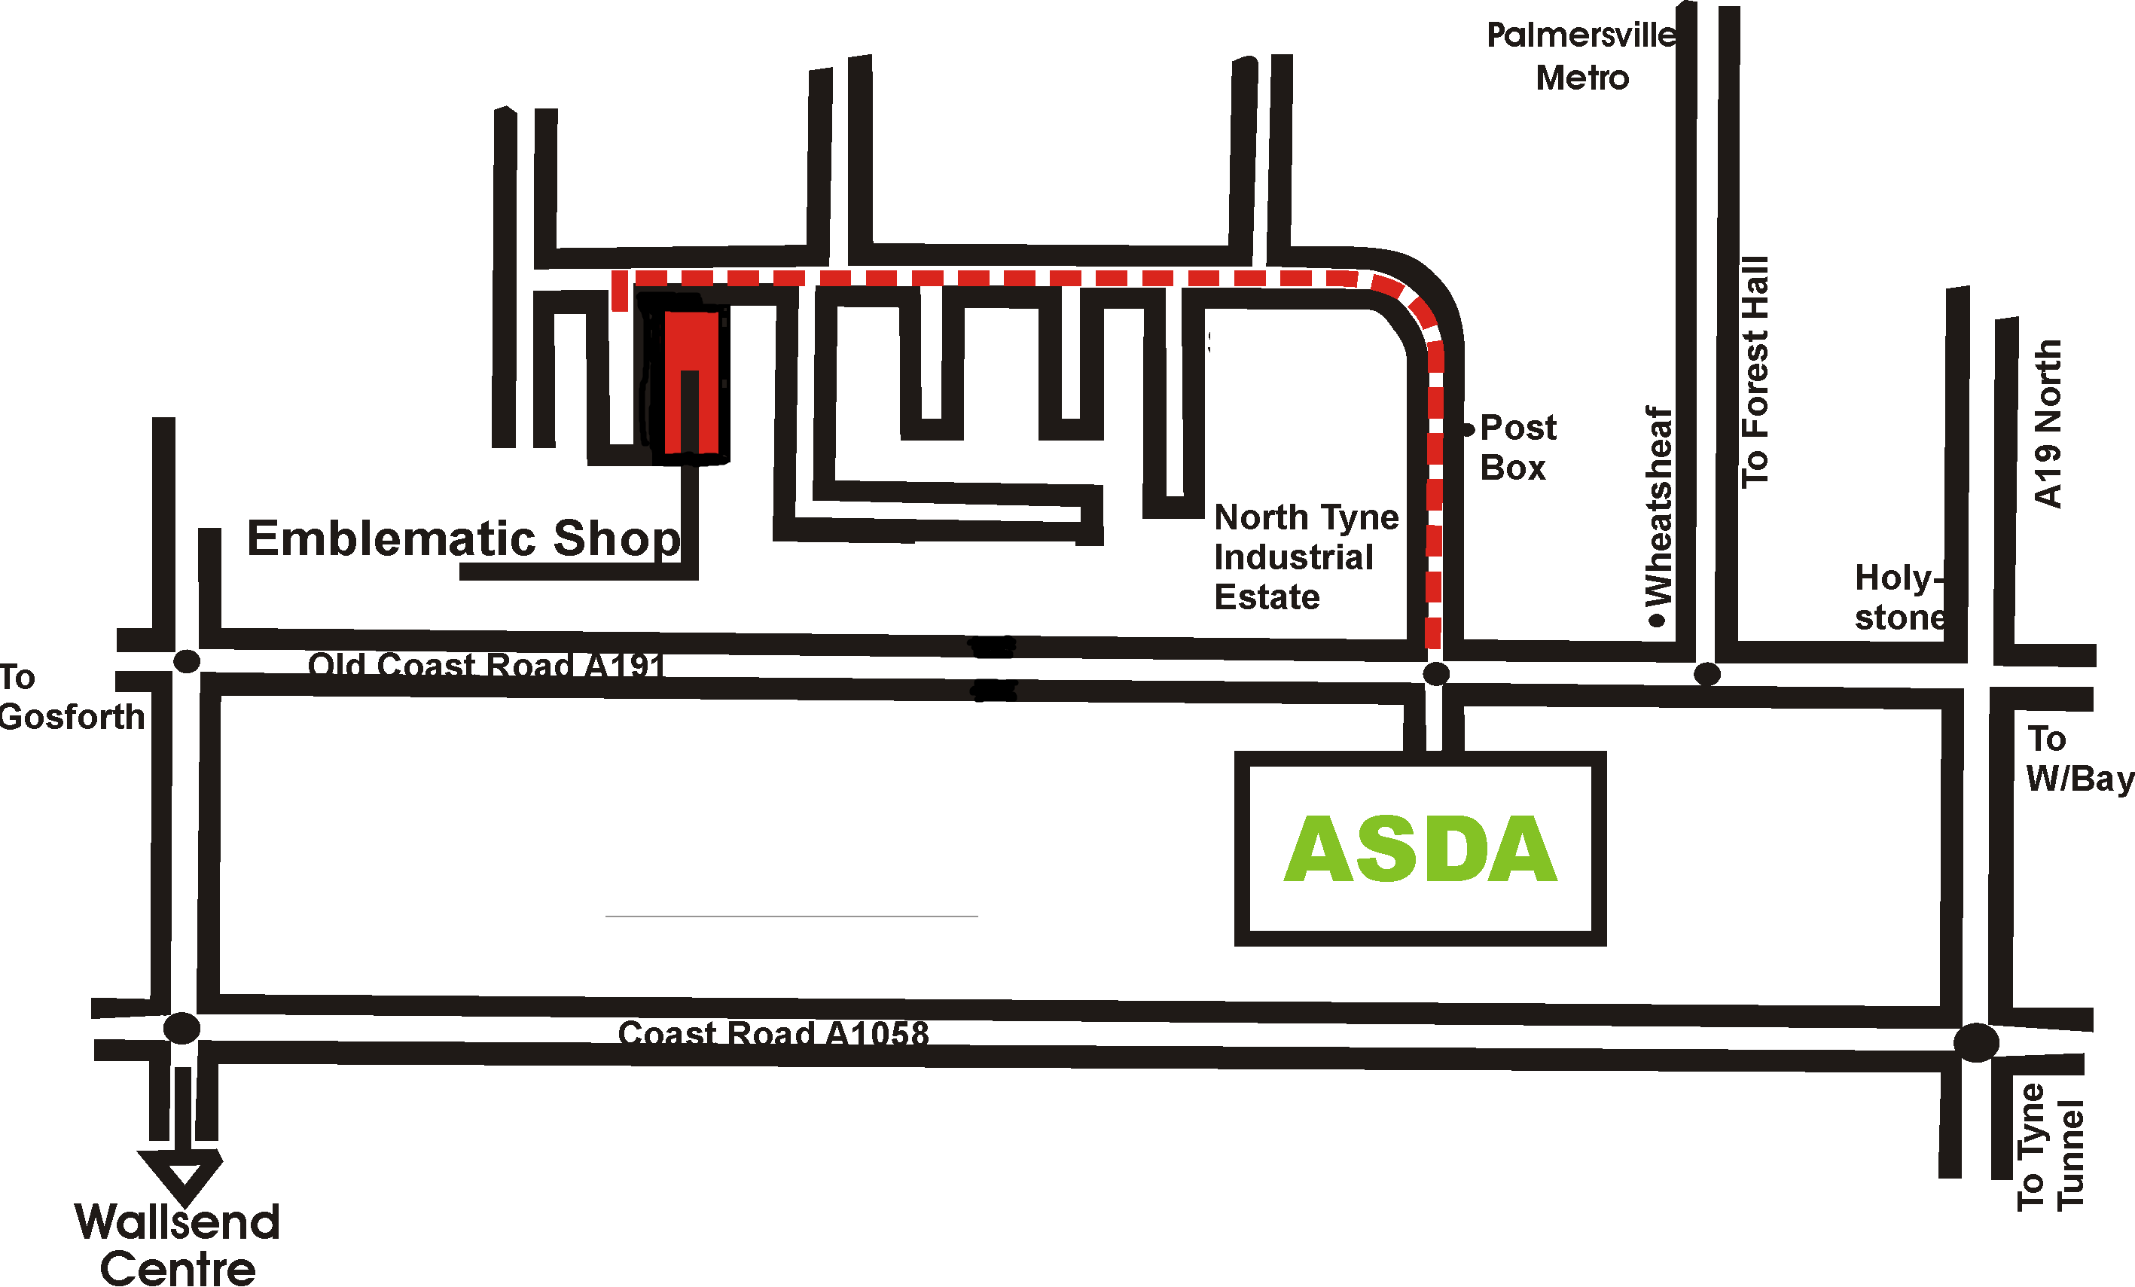

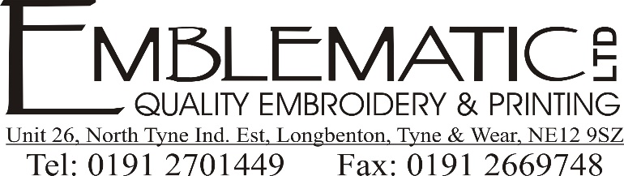

PE KIT ORDER FORM

Order On-Line, and pay by credit-card at https://emblematic.co.uk/longbenton-store/hms1/

CODE | ITEM | SIZE | QTY | AMOUNT
Falcon  (R200) | BLACK/RED RUGBY SHIRT  26/28, 30/32, 32/34, 34/36 -£19.00  38/40, 42/44, 46/48 - £22.00
Falcon  (G920) | BLACK/RED POLO SHIRT  26/28, 30/32, 32/34, 34/36 -£13.00  38/40, 42/44, 46/48 - £15.00
AKOA  (MLS) | BLACK/RED MIDLAYER  9/10, XXSmall, XSmall- £19.50  Small, Med, Large, XL, 2XL, 3XL - £23.99
Mitre  (Prime) | BLACK SHORTS- NO LOGO  24/26, 26/28, 28/30 - £5.50  30/32, 32/34, 36/38, 40, 42 - £6.50
Mitre  (MYP-RED) | RED FOOTBALL SOCKS  Shoe Size: 12-2(Mini), 3-6(Junior) - £4.50  Shoe Size: 7-12(Senior) - £5.50
Chadwicks | BLACK TRACKSUIT BOTTOMS- NO LOGO (OPTIONAL)  SY (8/9), MY (10/11), LY (12/13) - £14.00  XSmall, Small, Med, Large, XLarge - £15.00
Chadwicks | BLACK BASE LAYER – NO LOGO  (OPTIONAL)  Myth (10/11), LYth (12/13) - £13.75  XLY/XS (32/34), S (34/36), M (38/40), L (42/44) - £16.00
P&P | Postage & Packaging  (1 Item £2.99) (2 items or more £4.99)
 |  | TOTAL AMOUNT |  | £

OFFICE USE ONLY
PAYMENT INFORMATION
Method: | Cash: |  | Card:
DATE: | / / 2018
STAFF INITIALS:

NO MINIMUM ORDER

Student Name: | Phone:
Parents Name: | Mobile:
Address:  Postcode: | Sign & Date:

