Challenge 1
This is half of Lee's strawberries.

How many strawberries does Lee have?

This is half of Lee's shape.

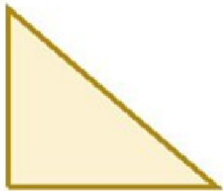

What could the whole shape look like?

Challenge 2
Tim buys a lolly and a chew.

c\-\E\N

The lolly costs 12p more than the chew. The total cost of the two items is 82p. How much does the lolly cost?

Challenge 3
Stickers come in packs of 5. Max buys 12 packs.

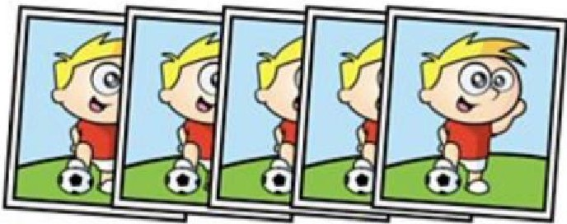

He gave his three friends some stickers. They each receive the same number.
He has 27 stickers left.

How many stickers did Max give each of his friends?

Challenge 4
Here are 3 containers.

.■,I

-

- The jug can hold 1500 ml.
- The bucket con hold 2 litres.
- The barrel can hold 15 litres.

Anisa wants to fill thebarrel with water.

Find 2 ways that Anisa can fill thebarrel using the jug and bucket.

Challenge 5
Three ident ica l squares are arrange to make this patt ern.

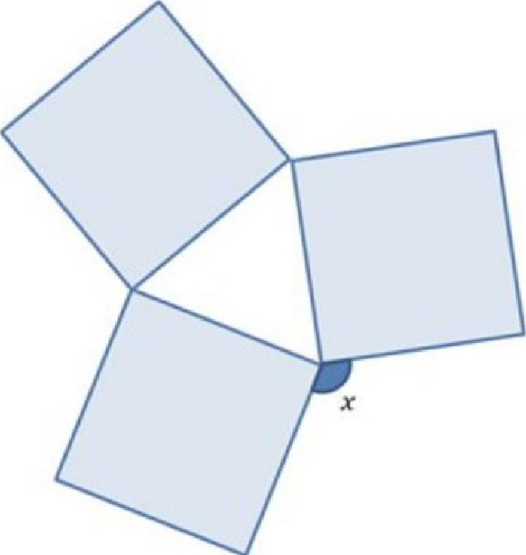

What is t he size of the angle marked x?

Challenge6
Here is a 3 x 3 grid with some shapes in.

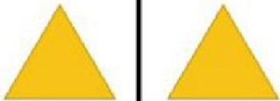 108
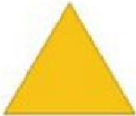

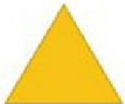 102

Each shape represents a number.

The sum of each row is shown at the right of the t able. Find the value of each of the shapes .

Challenge 7

Megan puts 4 fractions in order, starting with the smallest.

- I 8 s
7
2

She has spilt some paint on some parts of the fractions. What could the missing numbers be?

Challenge 8

Connor has five times as much money as Jayden. Connor gives some money to Jayden.
They now have £8.52 each.

How much did Connor have at the start?

Hint: The diagram below may help you.

I I I I I

□

Challenge 9
Here are two triangles identical in size.

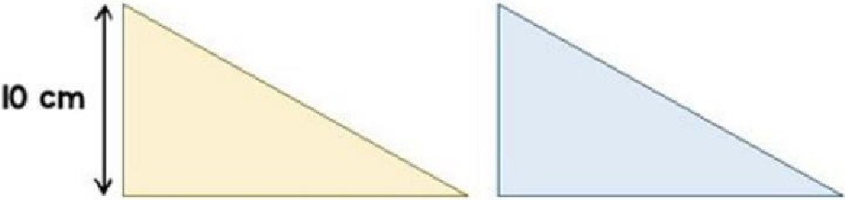

The two t riangles are overlapped.

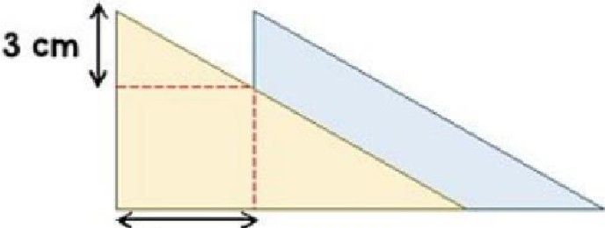
6cm

What is the area of the blue t riangle sh owing?

Challenge 10
80 people take port in a race.
- The ratio of children to adults in the race is 2:3 .
- The mean time for the adults is 2 minutes 15 seconds.
- The mean time for all 80 people is 3 minutes.
Find the mean time for the children.

As a rough guide of difficulty level:

- Challenge 1 and 2 are suitable for ages 5 to 7.

- Challenge 3 to 6 are suitable for ages 7 to 11.

- Challenge 7 to 10 are suit a ble for ages 11 to 15.

We want everyone to get involved with challenge day, so work together to solve as many as you can and share your so lut io ns!

