Starter
Which three words best describe you?

Be prepared to explain why this word is appropriate.
(If none of these words apply, provide three of your own!)

Friendly

Apprehensive
Shy Energetic
Lethargic

Approachable
Serious

Helpful Enthusiastic
Cautious

Passionate
Timid
Thoughtful
Lazy

To help your new English teacher get to know you, today you’re going to produce a piece of writing about yourself.

This writing should reflect your best effort:

- Neat handwriting
- Clear presentation
- Challenging, impressive vocabulary
- Detailed, with a range of sentence structures and punctuation.

Underneath your date and title, write:

- Your name
- Your Primary School
Everything should be neatly underlined.

Wednesday 3rd July A day in the life
Mia Smith
Ravenswood Primary School

Paired Task
A day in the life of…

A day in the life of Mia Smith.
Every morning at 7am the alarm on my phone shrieks incessantly, until I finally peep my head from under the covers and open my eyes. If I’m lucky, I can already smell the smoky wisps of sizzling bacon vapours drifting tantalisingly up the stairs; usually, this is enough to prompt me to bounce out of bed!
After a filling breakfast and a friendly chat with my Nan, I dash in and out of the shower, throw on my sapphire blue school jumper and race out of the door to grab the bus. As I make my way down the high-street, I usually stop to meet one or two friends along the way. Even though it’s only 8am, the street is already alive with shoppers buzzing in and out of doorways like bees; everyone seems in a rush to reach their intended destination on time, but my friends and I meander slowly to the bus stop and wait for the 62. Before long, it comes chugging down the street, already crammed full of sleepy passengers, and we squeeze our way on to find seats together.

Discuss:
1. With someone at home, read the start of Mia’s day. On paper, write down any vocabulary you think is effective.
What makes this a good piece of writing?

What might this student go on to write about next?

Gather together your ideas to use in each section of the narrative. Some examples are provided below:
Morning
Laughing and gossiping, we
Journey
stroll…
There’s usually a bitter wind…
Breakfast is scrumptious…
Crawl out of bed…
School day
Evening
Usually, I’m engrossed…
My favourite part of the day is…
After school, I
dedicate time to…
Individual Task

You are going to write your own ‘A Day in the Life of…’ narrative for your new teacher.

Divide your paper into four and lay it out as shown below:

Morning
Journey to school

School day
Evening

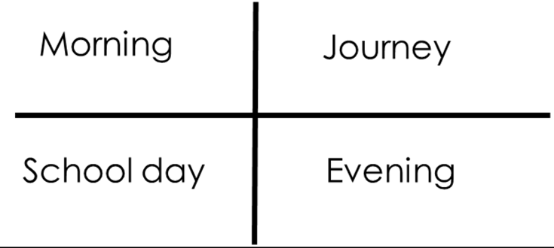
Individual Task

You are now going to compose your narrative for your new English teacher.

Remember:

  - Neat handwriting
  - Clear presentation
  - Challenging, impressive vocabulary
  - Detailed, with a range of sentence structures and punctuation.

  - Top tip: use paper to do rough work to keep you lined paper neat!

Paired Task

Reading work aloud is the best way to proof read for mistakes.

Read your work with someone at home, checking for mistakes as you do.

What have you learned about each other? Be prepared to share!

