LOOKING FORWARD TO DESIGN TECHNOLOGY

Throughout your time at primary school you will have designed and made various products.

Task 1:  Make a list of all the tools and equipment you have used in primary school | Task 2:  Describe the best design/make activity you took part in while in primary school.
Task 3:
When you get to Jesmond Park Academy you will have access to DT workshops. Tell us what are you most looking forward to doing in the DT department?

WELCOME TO OUR DESIGN TECHNOLOGY WORKSHOPS

The picture on the left is of a DT workshop at Jesmond Park Academy. Workshops are very different to normal classrooms like the one shown on the right. Look at the two pictures below and think about how the two rooms are different.
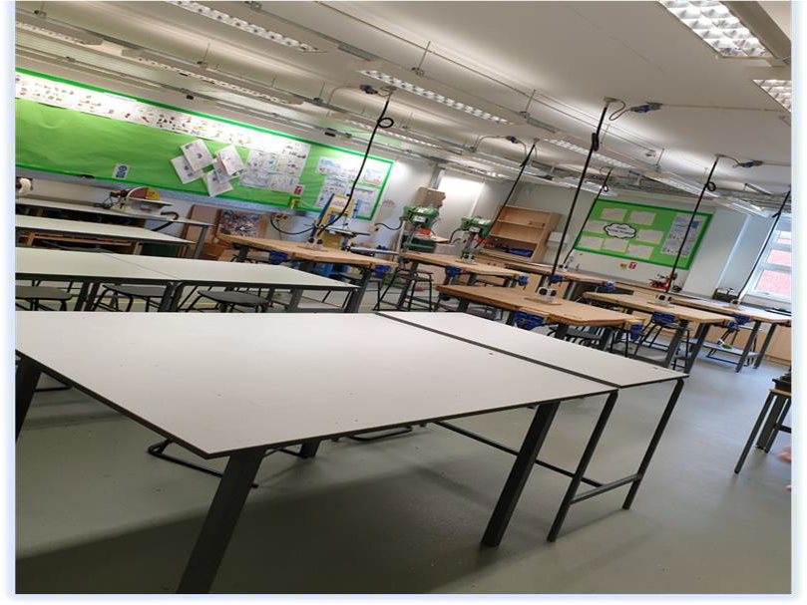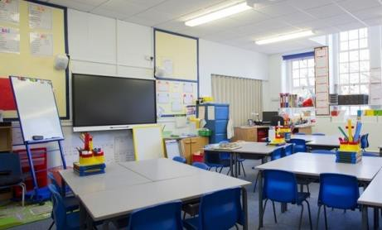
Task:
Can you explain why the rooms need to be so different?

SAFETY IN OUR DESIGN TECHNOLOGY WORKSHOPS

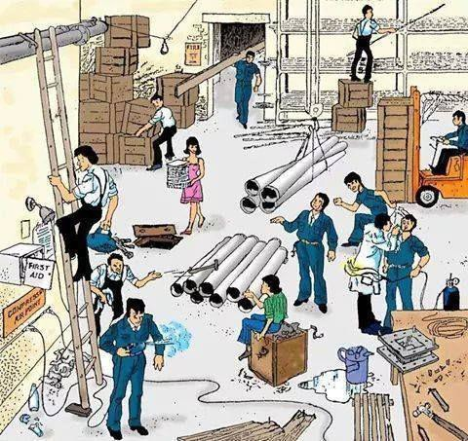Safety is the most important part of a DT lesson. The first thing you will learn in Year 7 will be how to act safely and responsibly in the workshop. Below is a picture of a workplace from a time when health and safety wasn’t very important!
Task:
How many hazards can you spot in the picture?

Using a red pen or pencil circle all the hazards.

SAFETY IN OUR DESIGN TECHNOLOGY WORKSHOPS

To stay safe in DT there are a number of rules students must follow.

Workshop Rules:
- Always listen to instructions
- Line up outside single file
- No entry to the workshop without a teacher
- Coats and bags stored as you enter the room
- No eating or drinking
- Walk into the workshop

During practical sessions
- Report anything you think is dangerous to the teacher immediately
- Always wear aprons
- Wear goggles when on a machine or soldering
- Tie back long hair
- Stack all stools safely out of the way
- Do not touch or use anything unless you’ve been trained
- Always tidy all tools back to the correct place

SAFETY IN OUR DESIGN TECHNOLOGY WORKSHOPS

Task:
Design a safety poster that could help students remember the rules.

Match the tools
Tenon Saw
Wood Plane

During your time at Jesmond Park Academy you will get to use a lot of new and interesting tools and equipment. Take a look at the tools below:

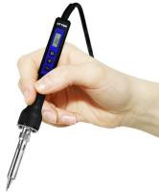
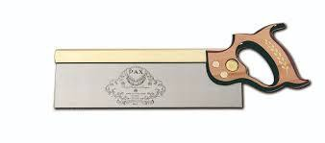
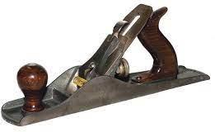
Claw Hammer

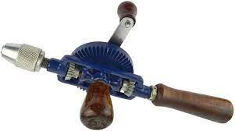
Hand Drill

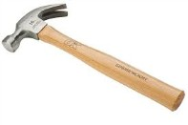
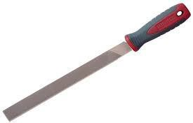
File
Soldering Iron
Task:
Draw a line from the name to the correct tool. The first one has been done for you.

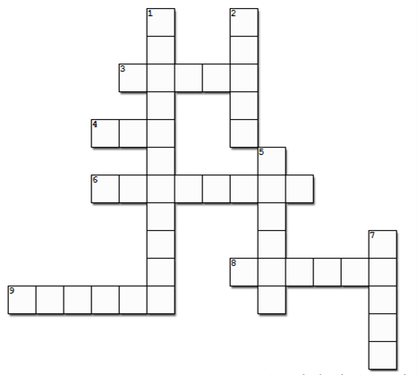
DT CROSSWORD

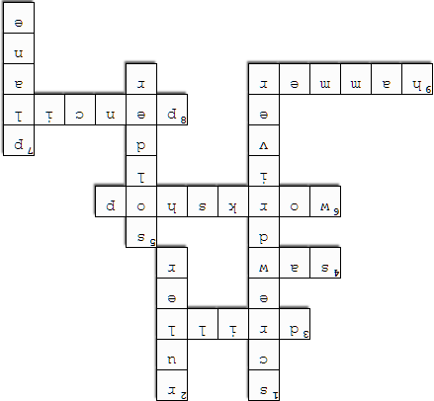
Flip for answers

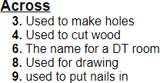
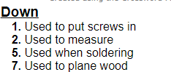

Task: Complete the crossword

