Tick all the shapes that are an enlargement of shape A.
3

Calculating scale factors

- 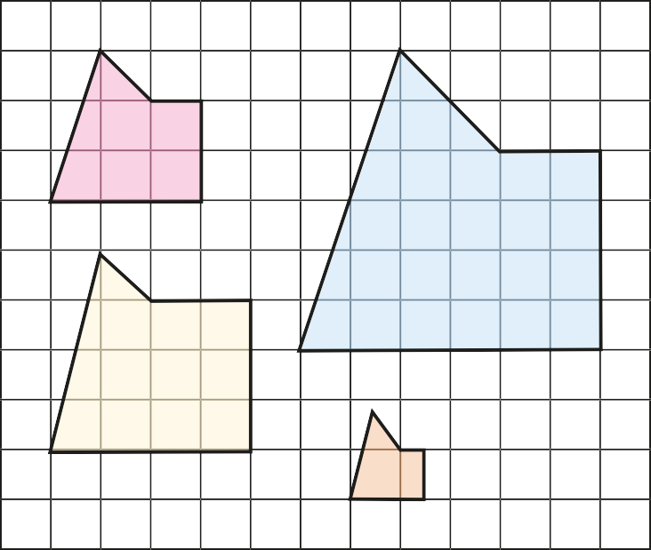Complete the sentences.
A
C
B
D

A

D
B

C How do you know which shapes are enlargements?
4

Shape B is an enlargement, by a scale factor of Shape C is an enlargement, by a scale factor of Shape D is an enlargement, by a scale factor of
, of shape A.

, of shape A.

, of shape A.

The two triangles are similar. Find the length of a.

- 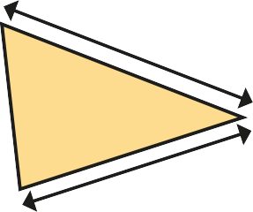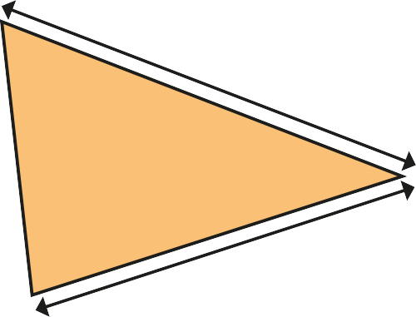Shape B is an enlargement of shape A. Shape C is not an enlargement of shape A.
7 cm
5 cm
a
15 cm

A
C

B

a = cm

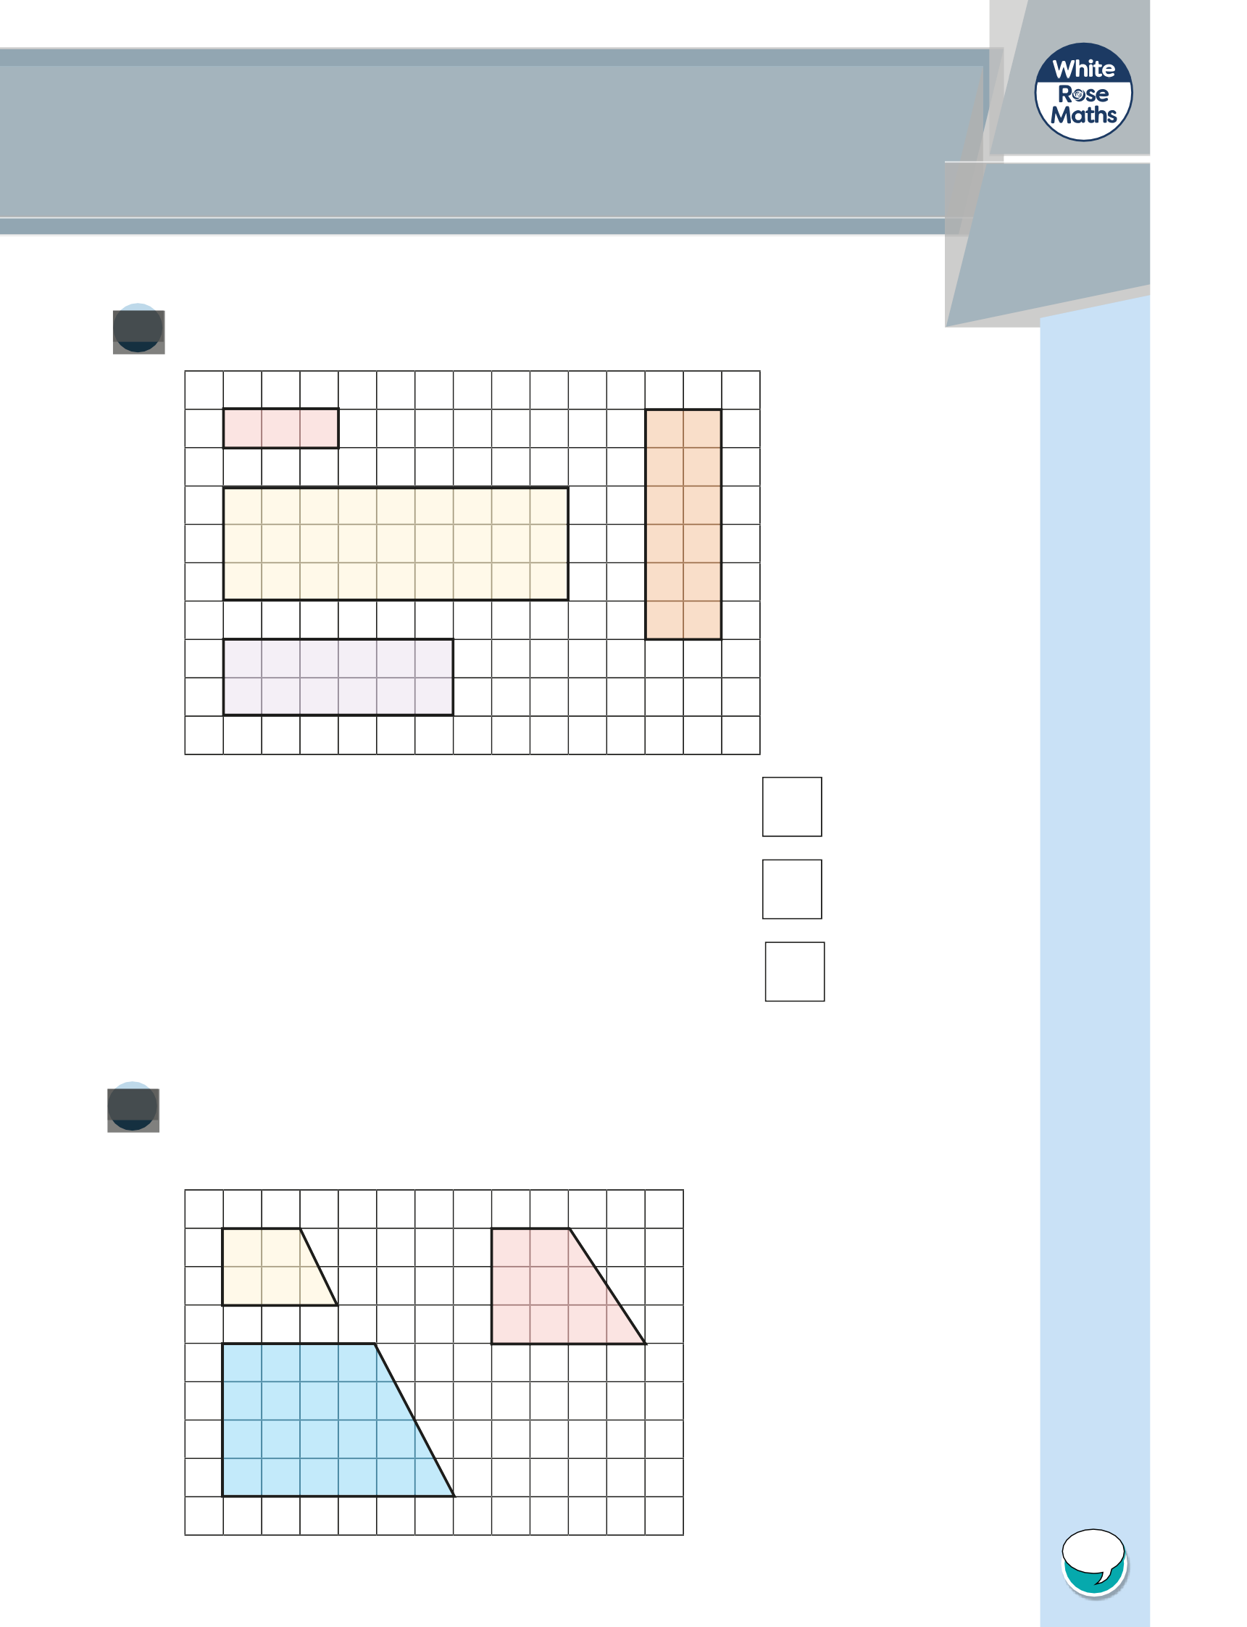
Talk to a partner about why this is the case.

© White Rose Maths 2019

7
The rectangle is enlarged by a scale factor.
The perimeter of the enlarged rectangle is 64 m.
What is the scale factor of
enlargement?
2.8 m
5.2 m
scale factor =
8
The diagram shows three similar triangles.
Calculate the missing values.
53°
b
21 mm
d
a
37°
c
6 mm
18 mm
27 mm
a =
b =
c =
d =
© White Rose Maths 2019

The two triangles are similar.
5
Find the area of the smaller triangle.

30 cm

4 cm 24 cm

area = cm2

These two children’s toys are similar. Find the length marked y.
6

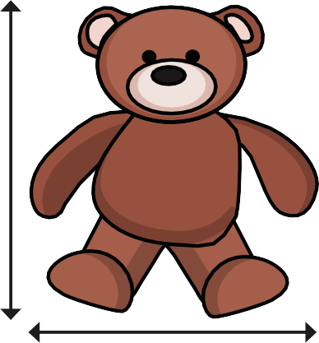
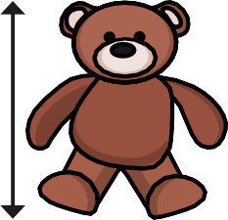
20 cm
5 cm

18 cm y

y = cm

